ASSIGNMENT NO.: 1
PRN: 260740150018
NAME: PRATIK SUNIL ABHANG
Q1. Question: What is Cloud Computing?
Answer / Solution
Cloud computing is the delivery of computing services over the Internet. These services include servers, storage, databases, networking, software, and other computing resources. Instead of buying and maintaining physical hardware, users can use resources from a cloud provider when they need them.
Examples of popular cloud providers are AWS, Microsoft Azure, and Google Cloud.
Example
A student uses Google Drive to store notes and assignments. The files are stored on cloud servers and can be opened from a laptop or mobile phone through the Internet.
Q2. Question: Why to use Cloud Computing?
Answer / Solution
Cloud computing is used because it provides computing resources quickly and makes them easier to manage. It is useful for students, companies, websites, applications, and many other services.
• No upfront infrastructure cost – There is less need to buy expensive servers, routers, and data-center equipment.
• Easy access – Applications and data can be accessed through the Internet from different locations.
• Instant scalability – Server capacity can be increased or decreased according to the workload.
• Global reach – Applications can be made available to users in different locations.
• High availability – Cloud providers can use multiple systems and data centers to reduce service interruptions.
• Less hardware management – The cloud provider manages much of the physical infrastructure.
• Faster setup – Servers and other resources can be created quickly.
• Backup and recovery – Cloud services can make data backup and recovery easier.
Example
A company starting a new website can rent a cloud server instead of buying a physical server. If website traffic increases, it can add more cloud resources without buying new hardware.
Q3. Question: What are the benefits of cloud computing?
Answer / Solution
• Cost efficiency – Pay-as-you-go pricing can reduce spending on unused hardware.
• Scalability – Resources can be increased or decreased when required.
• Flexibility – Users can work with cloud services from different locations and devices.
• Reliability – Cloud systems can use backup systems to reduce the effect of failures.
• Disaster recovery – Cloud backups can help restore data after a problem.
• Automatic maintenance – The provider handles much of the hardware maintenance.
• Fast deployment – Applications and servers can be set up quickly.
• Easy collaboration – Users can share files and work together online.
• Security features – Cloud platforms provide tools such as access control, encryption, and monitoring.
• Global availability – Services can be provided from data centers in different regions.
Example
Streaming platforms such as Netflix can increase cloud resources when many users watch a newly released show. When traffic becomes lower, resources can be reduced.
Result
Cloud computing helps organizations save cost, use resources efficiently, and provide services quickly and reliably.
Primary Cloud Service Models
The three common cloud service models are IaaS, PaaS, and SaaS.
Model | What It Delivers | Example Uses
IaaS (Infrastructure as a Service) | Virtual machines, storage, networking, and computing power. | AWS EC2, Google Compute Engine, Azure Virtual Machines
PaaS (Platform as a Service) | A platform for developing and running applications; the provider manages much of the OS and runtime. | AWS Elastic Beanstalk, Heroku, Google App Engine
SaaS (Software as a Service) | Ready-to-use software provided over the Internet. | Google Workspace, Microsoft 365, Dropbox
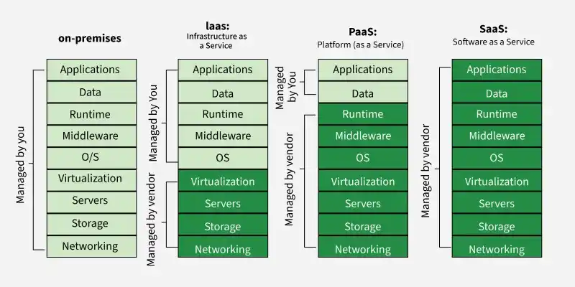
Q4. Question: What is the difference between paravirtualization and full virtualization?
Answer / Solution
Virtualization allows one physical computer or server to run multiple virtual machines. A hypervisor is the software layer that manages these virtual machines.
Full virtualization provides a complete virtual hardware environment, so the guest operating system normally does not need to be changed. Paravirtualization allows the guest operating system to know that it is virtualized and communicate with the hypervisor using special interfaces called hypercalls.
Comparison Table
Point | Full Virtualization | Paravirtualization
1. Guest OS awareness | Guest OS normally does not know it is virtualized. | Guest OS knows it is virtualized.
2. Guest OS modification | Normally no modification is required. | Usually requires modification or virtualization-aware support.
3. Hypervisor communication | Uses the virtual hardware provided by the hypervisor. | Guest OS can use special hypercalls to communicate with the hypervisor.
4. Performance | May have some virtualization overhead. | Can provide lower overhead in suitable cases.
5. Compatibility | Generally supports a wider range of standard operating systems. | Depends more on guest OS support.
6. Hardware view | Guest OS sees virtual hardware. | Guest OS is aware of the virtual environment.
7. Ease of running OS | Unmodified supported OS can usually be installed. | OS must support or be modified for paravirtualization.
8. Main advantage | Good compatibility and transparency. | Efficient communication and good performance.
9. Main limitation | May have more virtualization overhead. | Needs suitable guest OS support.
10. Example | Running an unmodified Windows OS in a virtual machine. | A virtualization-aware Linux guest communicating with a Xen hypervisor.

Example
Suppose a physical server runs Windows and Linux as virtual machines. In full virtualization, Windows can run without being specially changed for the hypervisor. In paravirtualization, the guest operating system is designed or modified to communicate with the hypervisor.

Result
Full virtualization focuses on providing virtual hardware without requiring guest OS changes. Paravirtualization focuses on cooperation between the guest OS and the hypervisor.
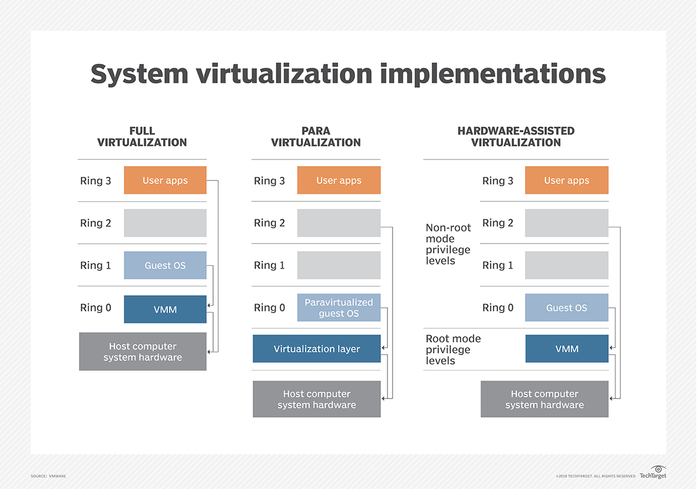
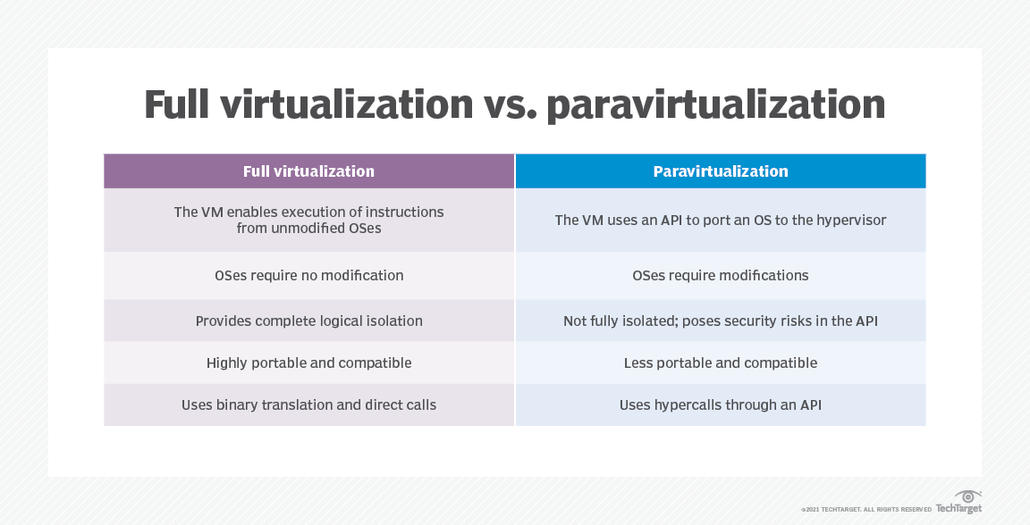
Q5. Question: What is the difference between delivery and deployment of a model?
Answer / Solution
In Machine Learning (ML) and MLOps, model delivery and model deployment are related but different activities.
Model delivery means preparing and making a trained model available for use. It can include packaging, testing, versioning, and storing the model as an artifact.
Model deployment means putting that model into a target environment where it can run and make predictions on real or new data.
Comparison Table
Point | Model Delivery | Model Deployment
1. Meaning | Makes the trained model ready and available for use. | Puts the model into an environment where it can run.
2. Main focus | Packaging, testing, and sharing the model. | Running and serving the model.
3. Main output | Model file, package, container, or registry artifact. | Live API, service, application feature, or running model.
4. Main users | Developers, testers, and DevOps teams. | Applications and end-users.
5. Packaging | Packages the model with required files and dependencies. | Uses the delivered package in the target environment.
6. Version control | Keeps track of model versions. | Selects and runs a particular model version.
7. Testing | Checks that the model package works correctly. | Checks that the model works correctly in the target environment.
8. Environment | Can be prepared in a registry or delivery system. | Runs on a server, cloud platform, device, or application.
9. Monitoring | May prepare the model for monitoring. | Usually requires live monitoring of performance and availability.
10. Example | Creating a Docker image containing the trained model. | Running that Docker image on a cloud service and providing predictions through an API.

Example
Suppose a company has a trained model that predicts whether a bank transaction is fraudulent. Packaging the model and its dependencies into a Docker image and storing it in a model/container registry is model delivery. Running that image on a cloud server and exposing an API for the banking application is model deployment.
Simple Difference
Delivery = preparing and making the model available.
Deployment = putting the model into a working environment so it can make predictions.
Result
Model delivery prepares and provides the model, while model deployment makes the model run and serve predictions in a target environment.

ASSIGNMENT NO.: 2
PRN: 260740150018
NAME: PRATIK SUNIL ABHANG
Q1. Question: Explain OpenStack components with communication flow diagram
Answer / Solution
OpenStack is an open-source cloud platform used to create and manage virtual machines, networks, storage, and other cloud resources. It is made of different services. Each service performs a specific job and communicates with the other services through APIs.
Component | Simple Purpose
Keystone | Provides identity, login, authentication, and service access.
Nova | Creates and manages virtual machine instances.
Neutron | Creates and manages networks, ports, routers, and security groups.
Glance | Stores and provides virtual machine images.
Cinder | Provides block storage volumes for instances.
Horizon | Web dashboard used to manage OpenStack.
Communication Flow Diagram
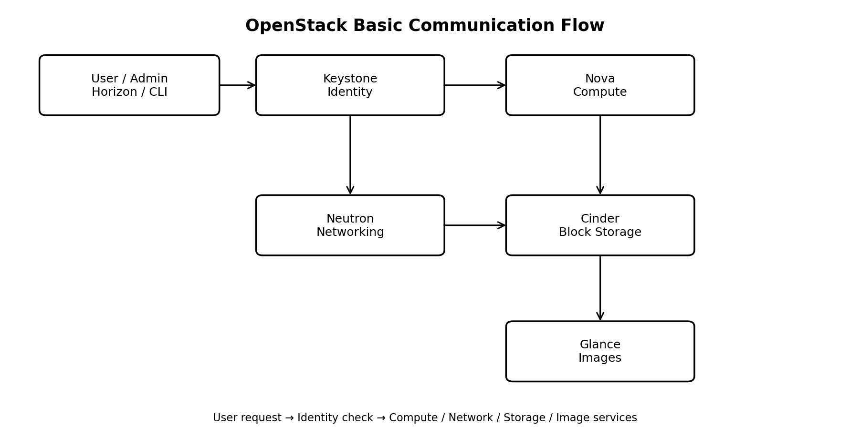
How the Communication Works
1. The user sends a request using Horizon, OpenStack CLI, or an application.
2. Keystone checks the user's identity and provides an authentication token.
3. The request is sent to the required service, such as Nova for an instance or Neutron for networking.
4. Nova can request an image from Glance and attach a Cinder volume to the instance.
5. Neutron provides the network, ports, and routing needed by the instance.
6. The services communicate through APIs and complete the requested operation.
Result
OpenStack uses separate services for identity, compute, networking, images, and storage. These services communicate through APIs to create and manage cloud resources.
Q2. Question: In OpenStack Create two instances with two separate volumes and network
Steps in Horizon
1. Log in to Horizon with the required project account.
2. Go to Project → Compute → Instances and click Launch Instance.
3. Enter a name such as Instance-1.
4. Select an available image, choose the required flavor, and select the required network.
5. Create or attach Volume-1 as the boot volume, depending on the available Horizon options.
6. Launch Instance-1.
7. Repeat the same process for Instance-2, but create/use Volume-2 as its separate volume.
8. Check that both instances are ACTIVE and each instance has its own volume.
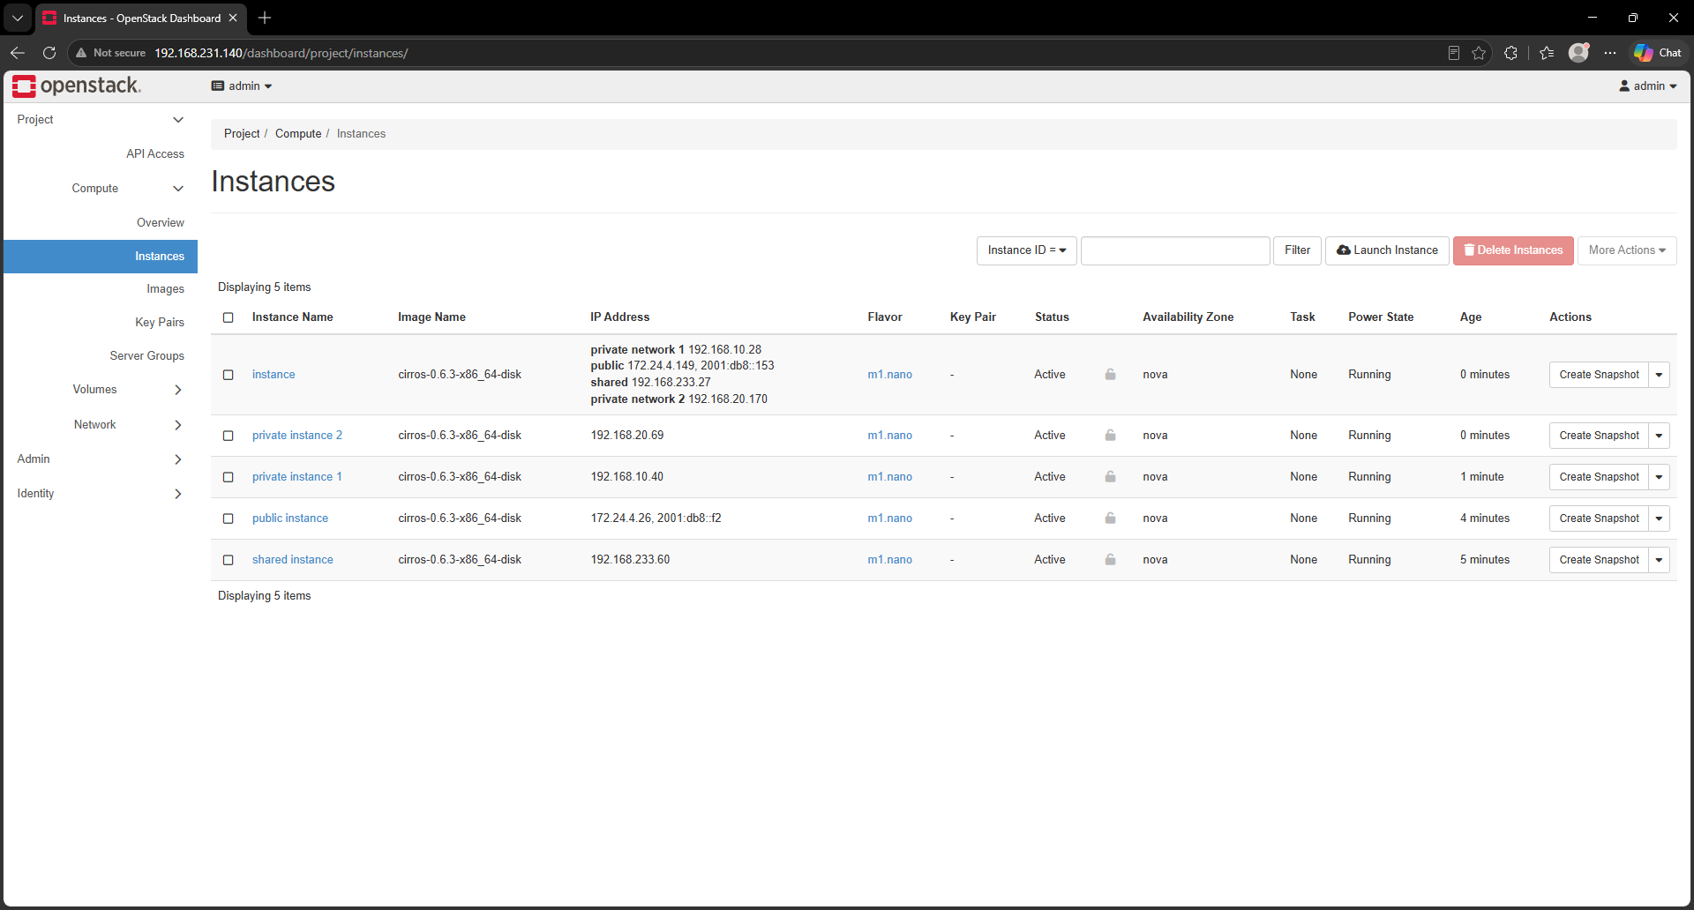Result
Two OpenStack instances are created successfully with separate volumes and network connectivity.
Q3. Question: Create internal and external network and assign it to routers and then instances
Steps
1. Open Horizon and go to Project → Network → Networks.
2. Create an internal network, for example Private-Network.
3. Create a subnet inside the internal network, for example 192.168.10.0/24.
4. Create or select an external network, for example Public-Network. The external network must be configured by the cloud administrator/provider.
5. Go to Project → Network → Routers and create a router, for example Router-1.
6. Open Router-1 and set the external gateway to Public-Network.
7. Add an interface to Router-1 using the Private-Network subnet.
8. Go to Project → Compute → Instances and launch or edit the instances.
9. Assign the Private-Network to the instances. The instances can then use Router-1 for external connectivity.
10. If external access to an instance is required, associate a floating IP from the external network with the instance port.
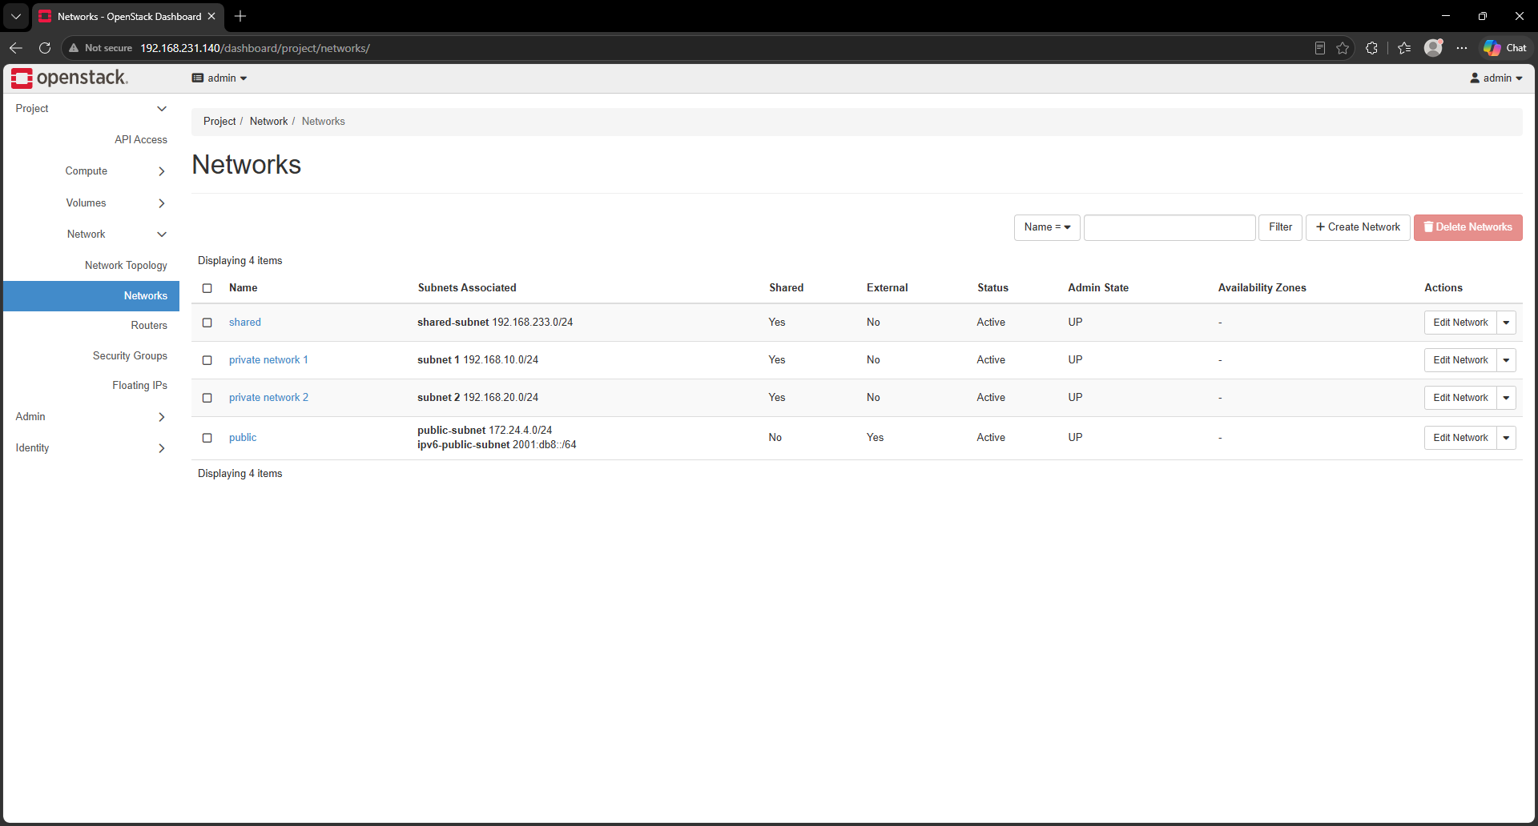Result
The internal network connects the instances, while the router connects the internal network to the external network. The instances can use the router for external connectivity when the required security rules and floating IP are configured.
DevStack Installation, Configuration & Web Access Guide
Section 1: DevStack Installation & Web Access
Step 1: System Package Update & Tool Installation
sudo apt update && sudo apt upgrade -y
sudo apt install -y git openssh-server
sudo systemctl enable --now ssh
sudo systemctl status ssh
Step 2: Create the Dedicated 'stack' User
DevStack should be run by a dedicated non-root user named stack.
sudo useradd -s /bin/bash -d /opt/stack -m stack
sudo chmod +x /opt/stack
echo "stack ALL=(ALL) NOPASSWD: ALL" | sudo tee /etc/sudoers.d/stack
sudo -u stack -i
Step 3: Clone DevStack and Configure local.conf
git clone https://opendev.org/openstack/devstack /opt/stack/devstack
cd /opt/stack/devstack
nano local.conf
Use a simple local.conf configuration such as:
[[local|localrc]]
ADMIN_PASSWORD=secret
DATABASE_PASSWORD=$ADMIN_PASSWORD
RABBIT_PASSWORD=$ADMIN_PASSWORD
SERVICE_PASSWORD=$ADMIN_PASSWORD
HOST_IP=$(hostname -I | awk '{print $1}')
Step 4: Execute DevStack Installation
./stack.sh
The installation time depends on hardware, network speed, and the services being installed. Wait for the script to finish successfully before using Horizon.
Step 5: Access OpenStack Horizon
hostname -I
# Open in a browser:
http://<YOUR_SERVER_IP>/dashboard
Username: admin
Password: secret
If the dashboard is configured on a different port or address, use the URL shown by the DevStack installation.

